When it came to looking for inspiration on how exactly the script would be outputted and how the final GUI would be displayed, we looked towards ‘Friendship Cards’.  ‘Friendship Cards’ originate from the ‘Relationships are Forever’ foundation based in Malta.  This is a non-profit, non-governmental organisation based in Malta which was founded by Julian and Joanna Sant Fournier. Their main ideals are that strong relationships are needed as the foundation for a strong and stable foundation. The primary objectives of this foundation is to help children, couples, and families build strong relationships through education, assistance and group activities which are then aimed at couples, whether they are married or not. This is done in order to help said couples build and develop life skills and communication skills with the objective of nurturing stable and long-lasting relationships. The foundation’s main vision is to promote and encourage communication between children and couples all around the world through various means. This includes even collaborating with other non-profit organisations and entities which are pursuing similar objectives, and through sharing and developing new tools and techniques in order to help build strong relationships. The organisation has created both ‘Friendship Cards’ and ‘Couple Cards’, however our main focus was on ‘Friendship Cards’ [1].

In order to achieve their goals when it comes to children, ‘Friendship Cards’ were developed with the intention for said children to enhance their abilities to build strong relationships with their families, friends and others that they will eventually come across in their lives. These cards come in different editions, with each edition focused on tackling different topics. When it comes to the first edition, which we were presented with, this edition tackles the subject of ‘Resolving Conflicts’ [2]. We held meetings and discussions with the creators of these cards to be able to understand exactly how they work and how we could apply them to our project. We were donated a set of these cards each and after looking into how they work exactly we took inspiration for our work. The goal of these cards is to make the user feel comfortable and say what they feel, realise that they may have said or done something wrong, and focus on taking steps in a positive direction in order to avoid hurtful behaviour in order to make up and become good friends again. These goals are reached through 4 different steps, also known as moods [3].

The cards are divided into 4 different moods, Feelings, Bad Moves, Good Moves, and Making up. Each mood has an associated color-coded cards and includes, ‘Things to talk about’ as suggestions. These would encourage the children to communicate better and eve discuss the particular situation which they would find themselves in. This is handled mainly through images in order to make it much more child friendly as can be seen with the front of the card which contains the mood, and the key message that that card would be trying to achieve. However, on the back of the card one would find the ‘Things to talk about’ which entails a list of open questions that may help the child to think and reach different conclusions thanks to the cards that they chose [4].

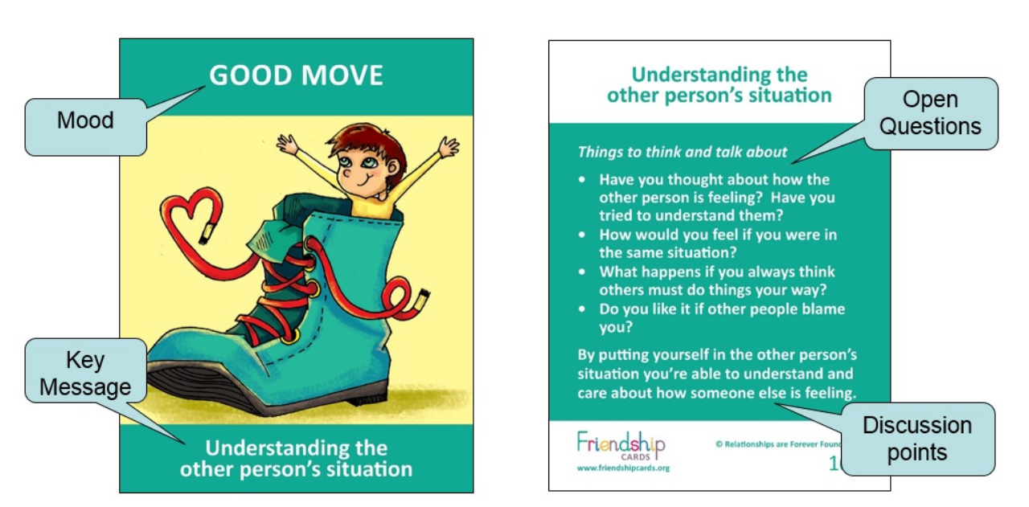

The creators of ‘Friendship Cards’ contacted us through the help of supervisor and personally sent us a set of their cards. We held meetings with Julian Sant Fournier personally and talked to him about the main points of interest that helped us to determine the final layout that our project needed to achieve. This included creating a software that was user friendly, mainly easy to understand by teachers, in order to possibly be introduced to classrooms in the future. We gave the user the ability to create any scenario possible by letting them creating a script of their choosing which through it our program will output said scenario with the imagery they would like. These would occur through automated means as the script is generated autonomously through parsing after the user has uploaded it, and if an image for a character or background is not in the preset database that we have created, the program will look it up and download the image itself and then apply it to the program as required.

Through our project we aim to be able to make using these friendship cards a simpler and easier task for any user, especially people who work with children directly, whether that be teachers, youth centers and so forth. Nowadays, a younger audience is often more interested in more interactive means and as such, a computer program could be more attractive to them.

[1] - https://www.friendshipcards.org/about/foundation/

[2] - <https://www.friendshipcards.org/about/about-us/>

[3] - <https://www.friendshipcards.org/overview/follow-the-steps/>

[4] - <https://www.friendshipcards.org/sample-card-layout/>

[5]